**DAILY ONLINE ACTIVITIES SUMMARY**

|  |  |  |  |  |  |  |  |
| --- | --- | --- | --- | --- | --- | --- | --- |
| **Date:** | **18/06/2020** | | | | **Name:** | **Syed Rabeya Aamir** | |
| **Sem & Sec** | **8th B** | | | | **USN:** | **4AL16CS112** | |
| Online Test Summary | | | | | | | |
| **Subject** | | **SMS** | | | | | |
| **Max. Marks** | | **60** | | **Score** | | **-** | |
| Certification Course Summary | | | | | | | |
| **Course** | **ANOMALY DETECTION ON AWS.** | | | | | | |
| **Certificate Provider** | | | **Aws** | **Duration** | | | **6 hrs** |
| Coding Challenges | | | | | | | |
| **Problem Statement:**  **1)**  Python Program to Add Custom Column to Tuple list . | | | | | | | |
| **Status: Solved** | | | | | | | |
| **Uploaded the report in Github** | | | | **YES** | | | |
| **If yes Repository name** | | | | **rabeya** | | | |
| **Uploaded the report in slack** | | | | **YES** | | | |

**ONLINE TEST:**

**Certification Course Details:**

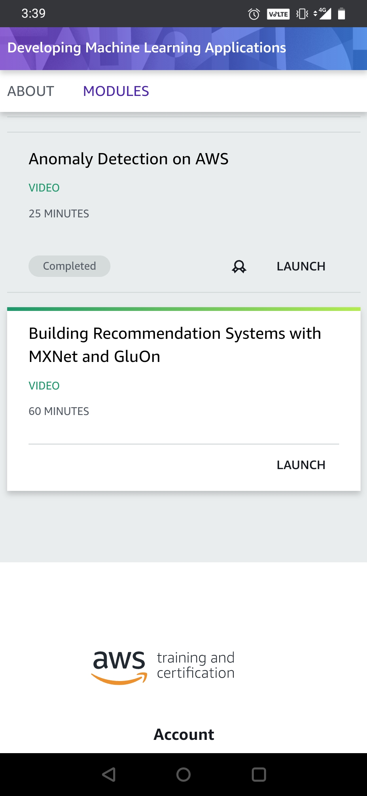

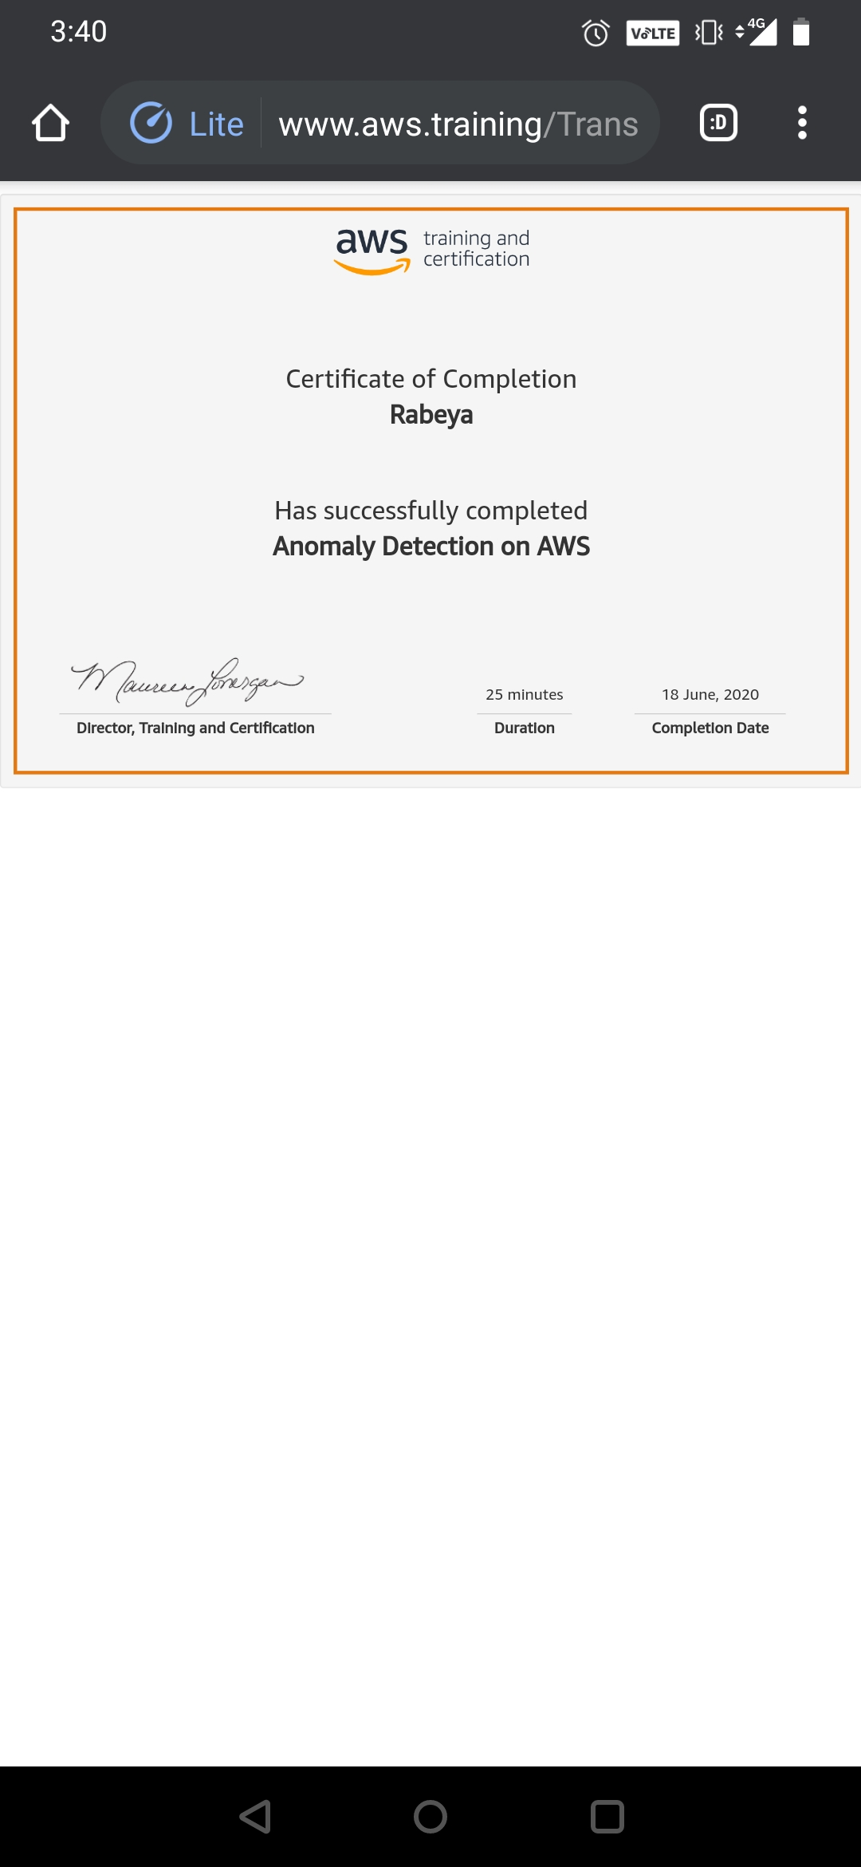

# CODE:

Program no:1

# Python Program to Add Custom Column to Tuple list .

test_list = [(3, 4), (78, 76), (2, 3)]

print("The original list is : " + str(test_list))

# initializing add list

cus_eles = [17, 23, 12]

# Add Custom Column to Tuple list

# Using map() + lambda

res = list(map(lambda a, b: a +(b, ), test_list, cur_eles))

# printing result

print("The tuples after adding elements : " + str(res))